Software Requirements Specification
Advanced Tic-Tac-Toe with SQLite and AI

1. Introduction
1.1 Purpose
This SRS document specifies the requirements for an advanced Tic-Tac-Toe game developed in C++ with SQLite for user management and game history, and AI opponents with varying difficulty levels. It serves as a contract between stakeholders and developers to define the system's functionality and constraints.

1.2 Scope
The Tic-Tac-Toe system is a console-based game supporting single-player (against AI) and two-player modes. Key features include:
- User registration and login with password hashing.
- Game play with a 3x3 board, supporting X/O symbols.
- AI opponents with easy, medium, and hard difficulty levels.
- Game history tracking using SQLite.
- Command-line interface (CLI) for user interaction.

1.3 Definitions, Acronyms, Abbreviations
- SQLite: Lightweight relational database management system.
- AI: Artificial Intelligence, referring to computer-controlled opponents.
- CLI: Command Line Interface.
- UML: Unified Modeling Language.
- Minimax: Algorithm for optimal AI moves.

1.4 References
- SQLite Documentation: https://www.sqlite.org/docs.html
- C++ Standard Library Reference: https://en.cppreference.com/w/
- IEEE SRS Template: IEEE Std 830-1998

1.5 Overview
This document covers the overall description, specific requirements, use cases, requirements traceability matrix, a general UML diagram section, and appendices.

2. Overall Description
2.1 Product Perspective
The system is a standalone C++ application with SQLite as an embedded database. It does not integrate with other systems but uses SQLite for persistent storage. It replaces traditional Tic-Tac-Toe with enhanced features like user accounts and AI opponents.

2.2 Product Functions
- Register and authenticate users with usernames and passwords.
- Allow two players to play Tic-Tac-Toe or one player against AI.
- Provide AI opponents with three difficulty levels: easy (random), medium (reactive), and hard (minimax).
- Store and display game history (win/loss/draw) for each user.
- Display a 3x3 game board and validate user moves via CLI.

2.3 User Characteristics
- Players: Casual users with basic CLI familiarity, no programming knowledge required.
- Administrators: Not applicable; no admin role exists.
- Users should understand Tic-Tac-Toe rules and numeric input (e.g., row/column coordinates).

2.4 Constraints
- Platform: Runs on systems with C++ compiler and SQLite library.
- Interface: Limited to CLI, no graphical UI.
- Database: SQLite for local storage, no network support.
- Security: Basic password hashing; not cryptographically secure.

2.5 Assumptions and Dependencies
- Assumptions:
- Users have access to a terminal/console.
- SQLite library is installed.
- Single-user local execution.
- Dependencies:
- C++ Standard Library (STL).
- SQLite3 C API.

3. Specific Requirements
3.1 Functional Requirements
FR1: User Registration
- Users shall enter a unique username and password to create an account.
- Passwords shall be hashed before storage.

FR2: User Login
- Users shall authenticate with username and password.
- System shall validate credentials against stored data.

FR3: Two-Player Game
- Two logged-in users shall play Tic-Tac-Toe on a 3x3 board.
- Users shall alternate turns, selecting empty cells by row/column.
- System shall detect win/draw conditions and save results.

FR4: Single-Player Game (AI)
- User shall play against AI with selectable difficulty (easy, medium, hard).
- AI shall make valid moves based on difficulty level.

FR5: Game History
- System shall store game outcomes (win/loss/draw) with username and timestamp.
- Users shall view their last 20 game results.

FR6: Move Validation
- System shall validate user moves (within 0–2 for row/column, empty cell).
- Invalid inputs shall prompt re-entry.

3.2 Non-Functional Requirements
NFR1: Performance
- Game response time shall be under 1 second for AI moves and board updates.
- Database queries shall complete within 100 ms.

NFR2: Reliability
- System shall handle invalid inputs without crashing.
- Database operations shall maintain data integrity.

NFR3: Usability
- CLI shall provide clear prompts and error messages.
- Board display shall be consistent and readable.

NFR4: Security
- SQL queries shall escape inputs to prevent injection.
- Passwords shall be hashed (though not cryptographically secure).

3.3 External Interface Requirements
- User Interface: CLI with text-based menus, board display, and input prompts.
- Hardware: Standard PC with console support.
- Software: C++ compiler, SQLite library.
- Communication: None; local execution only.

4. Use Cases
Use Case 1: Register User
- Actors: Player
- Flow: Player selects register, enters username/password. System validates uniqueness, hashes password, stores data.
- Preconditions: User not logged in.
- Postconditions: User account created.

Use Case 2: Login User
- Actors: Player
- Flow: Player selects login, enters username/password. System verifies credentials.
- Preconditions: User has registered.
- Postconditions: User logged in.

Use Case 3: Play Two-Player Game
- Actors: Player 1, Player 2
- Flow: Both players log in, select symbols (X/O). Alternate moves, system validates and checks win/draw. Save results.
- Preconditions: Both players logged in.
- Postconditions: Game result saved, history updated.

Use Case 4: Play Against AI
- Actors: Player, AI
- Flow: Player selects AI mode, chooses difficulty and symbol. Alternates moves with AI, system validates and checks win/draw. Save results.
- Preconditions: Player logged in.
- Postconditions: Game result saved, history updated.

Use Case 5: View Game History
- Actors: Player
- Flow: Player selects history option. System displays last 20 games with username, result, date.
- Preconditions: Player logged in.
- Postconditions: History displayed.

5. Requirements Traceability Matrix (RTM)
Requirement | Use Case | Design Element
FR1 | UC1 | registerUser(), Users table
FR2 | UC2 | loginUser(), Users table
FR3 | UC3 | playGame(), checkWinner(), saveGameHistory()
FR4 | UC4 | playGame(), easyAIMove(), mediumAIMove(), hardAIMove()
FR5 | UC5 | viewHistory(), History table
FR6 | UC3, UC4 | playGame(), input validation loops

6. General UML Diagram
This section provides a high-level UML diagram to explain how the code works generally, illustrating key components and their interactions (e.g., class relationships or component flow).

General UML Diagram:
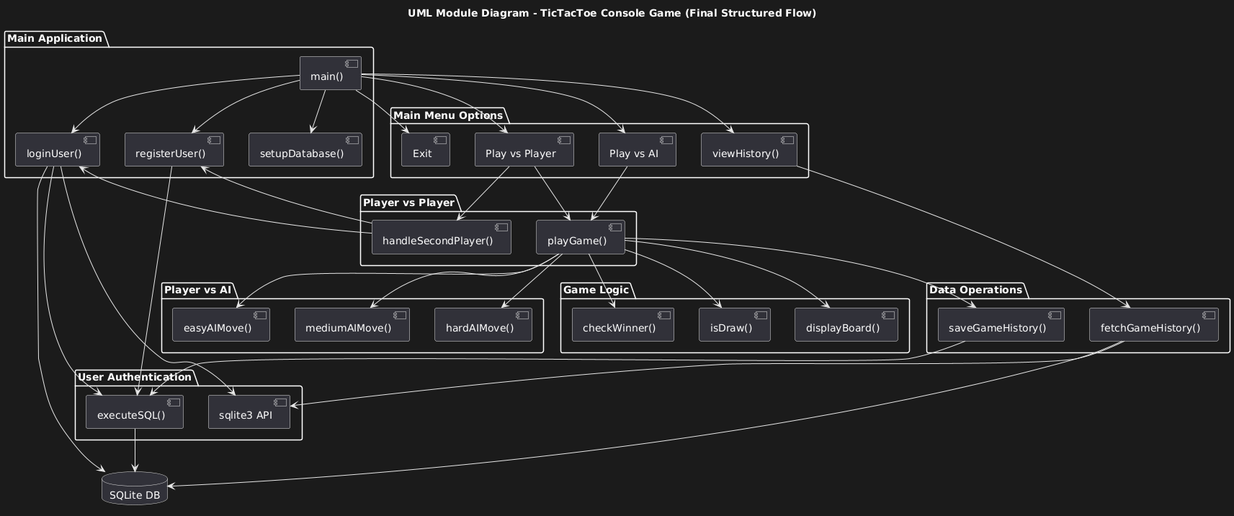
7. Appendices
7.1 Glossary
- Minimax: Algorithm for optimal AI moves by evaluating game outcomes.
- CLI: Command Line Interface for user interaction.
- SQLite: Embedded database for data persistence.

7.2 Analysis Models
ER Diagram (simplified):
- Users: id (PK), username (unique), password
- History: id (PK), username, result, date
[Placeholder for ER Diagram]

7.3 Future Enhancements
- Cryptographically secure password hashing (e.g., bcrypt).
- Networked multiplayer mode.
- Extended AI difficulty levels or board sizes.

